**Name: Session:**

**Programming II**

**Lab Exercise 3/20/2020 Stardate: 73215.85**

**Call Me the Tumbling Dice**

Start by creating the following Form. Your Form should contain 2 picture boxes that are visible and 6 picture boxes that are not visible. You will also need a button to initiate the roll. You also require a timer (Timer1) with Enabled set to false and Interval set to 100.

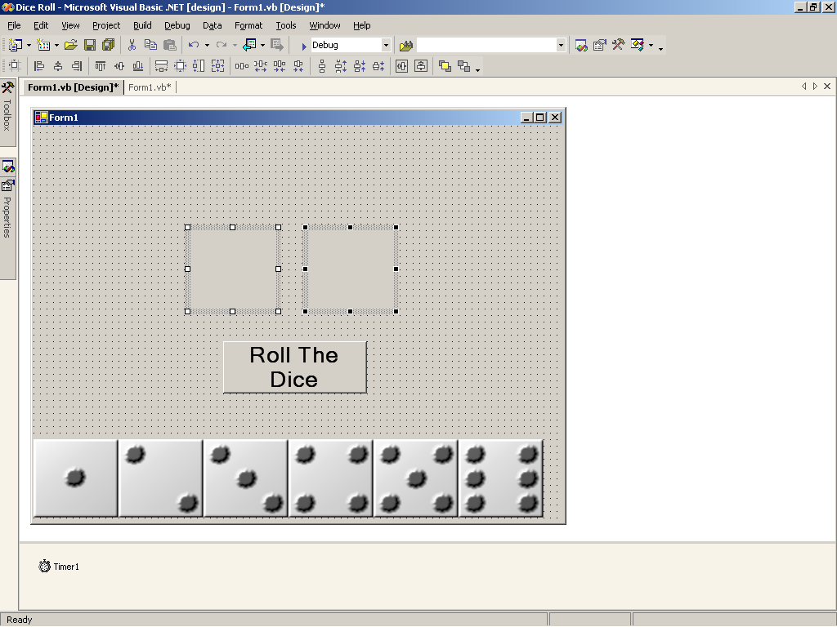

You will also need to store the 6 bitmapped images (Die1.bmp, Die2.bmp, Die3.bmp, Die4.bmp, Die5.bmp, and Die6.bmp) in your Project folder.

The two visible PictureBoxes should be named pb1 and pb2. The invisible Pictureboxes should be arranged along the bottom of the form and labeled Die1, Die2, Die3, Die4, Die5, and Die6.

Declare the following variables global to your Form.

int roll1, roll2, rolls, point;

bool firstRoll = true;

Random r = new Random();

Add the following code to your Form1_Load subprogram.

pb1.Image = die6.Image;

pb2.Image = die6.Image;

Add the following code to your btnRoll_Click event.

timer1.Enabled = true;

Add the following code to the Timer1_Tick event.

RollDie1();

RollDie2();

rolls++;

if (Rollover())

{

Rolls = 0;

timer1.Enabled = false;

//Uncomment PlayGame function call to implement the game

//PlayGame();

}

Add the following Function to your Form code

private bool Rollover()

{

if (Rolls > 30)

return true;

else

return false;

}

Add the following 2 functions to your Form code.

private void RollDie1()

{

roll1 = r.Next(1, 6);

switch (roll1)

{

case 1:

pb1.Image = die1.Image;

break;

case 2:

pb1.Image = die2.Image;

break;

case 3:

pb1.Image = die3.Image;

break;

case 4:

pb1.Image = die4.Image;

break;

case 5:

pb1.Image = die5.Image;

break;

case 6:

pb1.Image = die6.Image;

break;

}

}

private void RollDie2()

{

roll2 = r.Next(1, 6);

switch (roll2)

{

case 1:

pb2.Image = die1.Image;

break;

case 2:

pb2.Image = die2.Image;

break;

case 3:

pb2.Image = die3.Image;

break;

case 4:

pb2.Image = die4.Image;

break;

case 5:

pb2.Image = die5.Image;

break;

case 6:

pb2.Image = die6.Image;

break;

}

}

Now test your program to see if it works. You should see your dice roll for 3 seconds and then come top rest. Try experimenting with different timer settings.

Now that you have your program working, design a craps game.

The rules for Craps are:

1. If you roll a 7 or 11 on the first roll (called the “come-out” roll), you win.
2. If you roll a 2, 3, or 12 (called “craps”) on the “come-out” roll, you lose.
3. If you do not roll a 7, 11 or “craps” on your first roll, the amount you roll is stored as “your point”.
4. On successive rolls, if you roll “your point”, you win.
5. If you roll a 7 on a roll after the first roll, you lose.